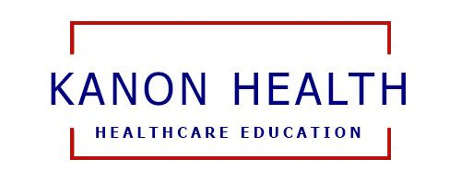
Kanon Health
2024-2025 Educational Scholarship Application

Name: ________________________________________

Cell phone: ____________________________________

Email address: _________________________________

Which educational event are you applying for:

_____ 2025 CEN Review Course _____ 2025 CPEN Review Course
_____ 2025 CCRN Review Course _____ 2025 Critical Care Nursing Congress
_____ 2025 APRN POC US Workshop _____ 2024 APRN Medication Seminar (Nov 16, 2024)

How would this education shape you to be a better clinician? (approx. 200 words)

_____________________________________________________________________________________________

_____________________________________________________________________________________________

_____________________________________________________________________________________________

_____________________________________________________________________________________________

_____________________________________________________________________________________________

_____________________________________________________________________________________________

_____________________________________________________________________________________________

The scholarship is provided by the Kanon Health Global Foundation. Proceeds from all virtual educational events go to support the global mission of the Foundation.

Partial scholarships may be awarded. Any remaining registration fee will be paid via Venmo.

Return application to:
Steven J Jewell at steven.jewell@kanonhealth.org

www.kanonhealth.org

